Registration Number: 23MCA10149

Email: mohit.23mca10149@vitbhopal.ac.in

Phone: +91 7277444964

[www.linkedin.com/in/mohit-srivastava-74649a221](http://www.linkedin.com/in/mohit-srivastava-74649a221)

<https://github.com/MohitSrivastava-149>

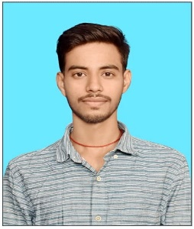

**Mohit Srivastava**

**Technical Skills:** Java, HTML/CSS, JavaScript, ReactJS, SQL

**Certification:**

* Java, SQL(Basic), Web Development

|  |  |  |  |
| --- | --- | --- | --- |
| **EDUCATION** | | | |
| **Board** | **Tenure** | **Educational institution** | **CGPA/Percentage** |
| MCA | Aug | Vellore Institute of Technology, Bhopal | - |
| BCA | July 2020- Aug 2023 | L N Mishra College of Business Management, Bihar | 70.78% |
| Class XII | April 2018 – Feb 2020 | M.B.B.L Inter College, Bihar | 66.6% |
| Class X | May 2018 | Paramount Academy Silout Bimal, Bihar | 71.6% |

|  |  |
| --- | --- |
| **ACADEMIC PROJECTS** | |
| Minor Project | * Gaming Portal using HTML, CSS and JS |

|  |  |
| --- | --- |
| CO-CURRICULARS | |
| Coding | * Solved 50+ questions in GeeksForGeeks |

|  |  |
| --- | --- |
| ADDITIONAL INFORMATION | |
| Hobbies | * Like Listening Podcast * Playing Cricket |
| Languages | * English, Hindi, Bhojpuri |